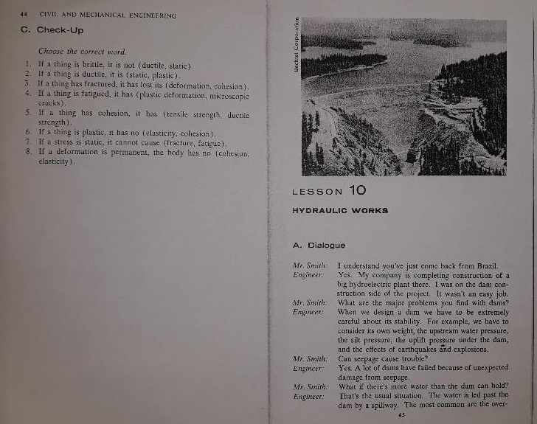
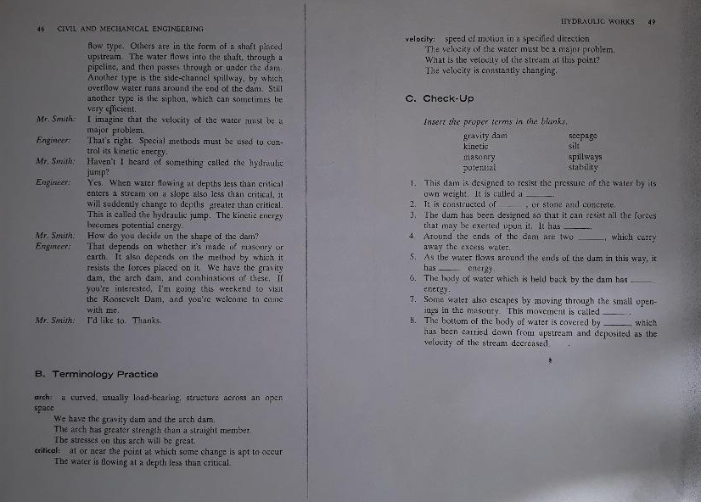

Present Simple - Passive
The passive is used when the object of a sentence is more important than the subject.
Compare:
The Queen rules Great Britain (Active)
Great Britain is ruled by The Queen (Passive)
To form the passive we use 'To Be' + past participle
Make passive sentences from the following information:
1. Fiat cars \ Italy \ make – Fiat cars are made in Italy.
2. Spaghetti \ boiling water \ cook - Spaghetti are cooked in boiling water.
3. Children \ schools \ educate - Children are educated in schools.
4. Football \ every country \ play – Football is played in every country.
5. Race horses \ jockeys \ ride – Race horses are ridden by jockeys.
6. Switzerland \ speak \ German- German is spoken in Switzerland.

Past Simple - Passive
James Cameron directed Titanic (Active)
Titanic was directed by James Cameron (Passive)
Make passive sentences from the following information:
1. 1937 \ ballpoint pen \ invent-
2. hospital \ open \ The Queen \ last week – Hospital was opened by the Queen last week.
3. car \ steal \ last night – Car was stolen last night.
4. what time \ he \ attack? – What time was he attacked?
5. we \ meet \ at the airport \ tour guide- We were met at the airport by a tour guide.

Simple Future Passive

Something done by someone in the future. ( will be + past participle)
Active : We will take the horses to the stable.
Passive: The horses will be taken to the stable.
Active : Will the manager sign the contract tomorrow?
Passive: Will the contract be signed by the manager tomorrow?

- Will he pick up the kids tomorrow?
Passive: Will the kids be picked up tomorrow?

- The birds will eat those cookies.
Passive: Those cookies will be eaten by birds.

- The coach will throw a party on the weekend.
Passive: A party will be thrown on the weekend by the coach.

4. The next earthquake will destroy the city.
Passive: The city will be destroyed by the next earthquake.

